# Fitflex

# 1.Introduction

projectTitle : Fitflex

Team ID : NM2025TMID35986

Team Leader : Suryaprasath P & [udcu24s1059@gmail.com](mailto:udcu24s1059@gmail.com)

Team Members:

1. Pragatheesh prasath G & [udcu24s105606@gmail.com](mailto:udcu24s105606@gmail.com)

2.Lenin victor K R & [udcu24s1055@gmail.com](mailto:udcu24s1055@gmail.com)

3.Chandru R & [udcu24s1075@gmail.com](mailto:udcu24s1075@gmail.com)

# 2. Project Overview

## • Purpose:

SB Works connects clients and freelancers through project postings, bidding, and real-time communication

## . • Features:

– Project posting and bidding

– Secure chat system

– Feedback and review system

– Admin control panel

# 3. Architecture

## • Frontend:

React.js with Bootstrap and Material UI

## • Backend:

Node.js and Express.js managing server logic and API endpoints

## • Database:

MongoDB stores user data, project information, applications, and chat messages

# 4. Setup Instructions

## • Prerequisites:

– Node.js

– MongoDB 2

– Git

– React.js

– Express.js – Mongoose – Visual Studio Code

## • Installation Steps:

# Clone the repository git clone

# Install client dependencies cd client npm install

# Install server dependencies cd ../server npm install

# 5. Folder Structure

SB-Works/

|-- client/ # React frontend

|__components/

L__ pages/

|__ server/ # Node.js backend

|__routes/

|__ models/

|__ controllers/

# 6. Running the Application

## • Frontend:

Cd client

npm start

## • Backend:

Cd server npm

start

## • Access: Visit <http://localhost:3000>

# 7. API Documentation

## • User:

– /api/user/register

– /api/user/login

## • Projects:

– /api/projects/create

– /api/projects/:id

## • Applications:

/api/apply

## • Chats:

– /api/chat/send

– /api/chat/:userId

## 8. Authentication

• JWT-based authentication for secure login

• Middleware protects private routes

## 9. User Interface

• Landing Page

• Freelancer Dashboard

• Admin Pane

• Project Details Page

## 10. Testing

• Manual testing during milestones

• Tools: Postman, Chrome Dev Tools

## 11. Screenshots or Demo

## 237d660d-6400-4407-b013-b7b98d1392bf.jpg

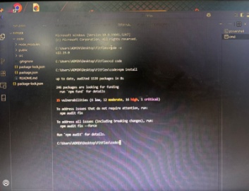

## 12. Known Issues : NILL

## 13. Future Enhancements:

sical activity. Key environmental features include the built environment, such as parks, trails, and bike lanes, and specific gym elements like good lighting, ventilation, clean facilities, and quality equipment. Perceptions of safety, aesthetics, and convenience are crucial mediators of how effectively these environmental features promote fitness activities.